Tableau IMDB Movie Ratings Demonstration

David Asare

These are graphs below of the IMDB movie ratings based on the Director Steven Spielberg.

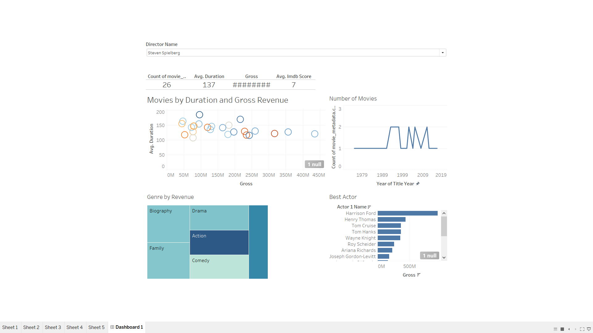

Link to the Tableau public display.

[Movie Ratings for IMDB | Tableau Public](https://public.tableau.com/app/profile/david.asare3490/viz/MovieRatingsforIMDB/Dashboard1?publish=yes)

Reference

<https://www.youtube.com/watch?v=xwO9xK4xUKM>